

|  |  |
| --- | --- |
| **Monkey Goes Bananas Game**  *“Eat bananas, go *pew pew*, gain your freedom!”* | **Abstract**  You play as a monkey who was being experimented on by humans in a lab. You finally manage to escape your enclosure but now must fight the humans in the lab to escape and gain your freedom!   * David Shlaifer * Sofia De Palma * Kaci Luu * Mikhayla De-Las-Alas |

**Table of Contents**

***Executive Summary*** 2

***Overview*** 2

***Related Games*** 3

***Player Composites*** 3

***World*** 4

***Characters*** 4

***Game Progression*** 5

***Art Direction*** 6

***UI Storyboard*** 7

***Tags & Dialogue*** 9

***Tech Plan*** 10

***Software Architecture*** 10

***Controls*** 10

***Level Design*** 10

***Mechanicals Analysis*** 11

***Schedule*** 12

***Budget*** 12

***Change Log*** 12

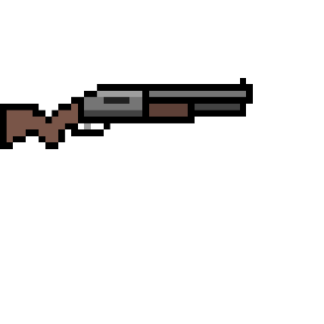******

# ***Executive Summary***

The game is set in a high-tech science laboratory.

It’s fast-paced, action-packed and

Our game is new and never seen before, super Mario mixed with Asteroids.

# ***Overview***

Drawing inspiration from games such as Asteroids (1979) and Super Mario Bros. (1985), this arcade-style single-player shooter game has players take on the role of a monkey who was being experimented on by humans in a lab. We decided to use the film Rise of the Planet of the Apes (2011) as inspiration for the story of our video game. The goal of the game is to fight through the map by shooting and eliminating evil lab employees in order to reach the end of the map where the player will face the final boss: the despicable head scientist. Additionally, as the game progresses, players will encounter boxes that may be destroyed to reveal one of two power-ups. The first and most common type of power-up is a banana. This power-up will temporarily increase the player’s strength by decreasing their damage intake; this power-up will be visualized by increasing the player’s size. The second power-up will be a bit rarer to encounter. This power-up will be represented as a lab vial filled with vibrant green fluid. If the player uses it, they will temporarily have an increased firing rate. Lastly, if the player manages to eliminate the final boss, they have won the game and have gained their freedom as a free monkey in the wild! Players will then see a winning screen with an image of a jungle background. However, if at any point during the playthrough they get caught, a losing screen with an image of a monkey (the player) behind bars will be displayed.

# ***Related Games***

***Super Mario Bros:*** With Super Mario Bros, we liked the pixelated aesthetic and the way you can get power-ups by hitting different boxes, so we used that as inspiration for our game and added the power-ups and the pixilated background to our game.

***Metroid***: With Metroid, we liked the fact that it portrayed shooting enemies with a gun and that they would disappear (almost explode). We took that aspect and added it to our game as well.



***Asteroids***: With Asteroids, we liked the potential to increase the firing rate. Combining this with the power-up concepts from Super Mario Bros, we added a power-up that increases the firing rate.

# ***Player Composites***

Thomas is a 15-year-old high school student who has found a way to play **Monkey Goes Bananas** during his lunch breaks at school. He sits at the back of the classroom, sneaking in gameplay whenever the teacher isn’t watching.

Becka is a young CEGEP student who enjoys retro games. Though her main focus is on school, she still finds some free time to play casual video games, specifically ones that are conveniently available online. Whenever she needs a quick break from doing assignments or studying, she likes to open short and simple games in a separate window to unwind and clear her mind off the stress of school.

# ***World***

This world will be shown first in a cell in a lab. Later, the character will enter other places of the world like the rooms of different areas of the lab and in the end being in a jungle. The world starts in a cell because the monkey was captured from its home, which was the jungle, and the scientists are trying to experiment on him. The monkey manages to escape and enters rooms where other monkeys were experimented on also, in other rooms there are boxes where power-ups are available for the monkey to defend itself, there is also a room where all the mini scientists are guarding, the room is the main scientist room. Entering this room, you will encounter the main boss who has the key to escaping the lab, when killing the boss, you will be able to exit and go back to the jungle, but if you never manage to beat the boss and he manages to defeat you, you will end up back in your cell.

# ***Characters***

* 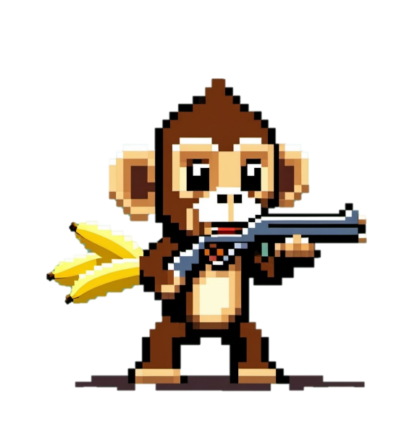**Main character** (only playable character): Monkey named *TBD*

When he was just a baby primate living in a beautiful South American tropical forest, the MC was cruelly captured for the specific purpose of being experimented on. Having been in captivity most of his life, he only knew the laboratory walls. The latest experiment suffered by the MC involved injecting him with a new, high-tech drug which has caused him to develop human-like intelligence, suddenly possessing intelligence levels that surpass those of an average person. Consequently, he has realized that he desires a life outside the lab; he deserves a life of freedom! His main enemy is the Evil Head Scientist. Additional enemies include the lab staff.

* **Une image contenant clipart, Animation, Dessin animé, dessin humoristique

  Description générée automatiquementMain enemy**: Evil Head Scientist

Motivated by sick sadism and his insatiable greed for wealth, the Evil Head Scientist collects multi-billion-dollar contracts from pharmaceutical companies who in turn request the testing of newly developed drugs on primates. The extremely unethical methods do not phase the scientist for his thirst for money and profoundly sadistic psyche override all morals.

# ***Game Progression***

1. **The Lab Cell:**

* 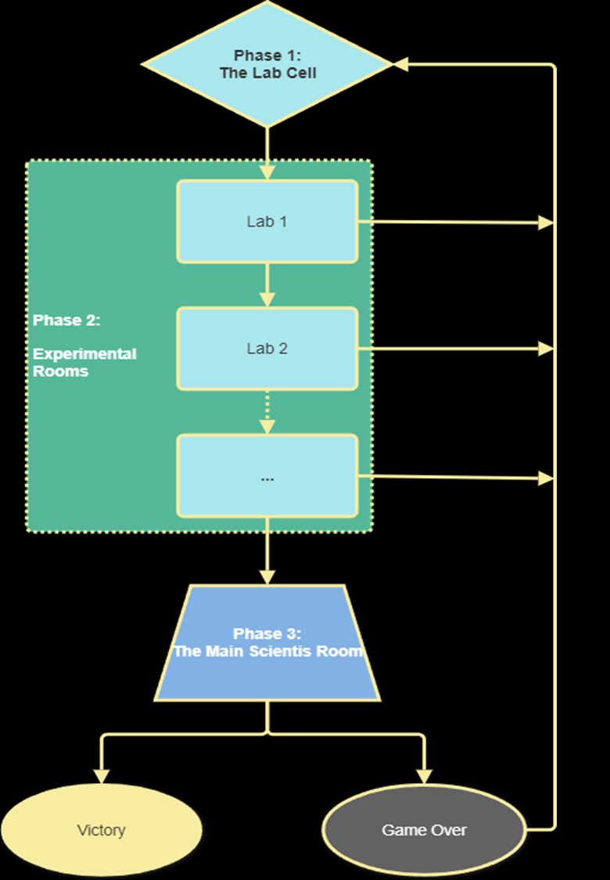**Intro:** Start in a dimly lit cell where the monkey is held captive.
* **Objective**: Escape the cell. Players will defeat some scientist guards to go to the next area (next stage).

1. **Experimental Rooms:**

* **Labs:** After escaping the cell, the monkey enters other rooms of the lab.
* **Combat:** Encounter lab assistants who try to recapture the monkey. Use power-ups to fight or evade them.

1. **Main Scientist Room:**

* **Boss office:** Face off with the main scientist. The key to escape is held by the boss. Players must defeat the scientist boss to take the key.

1. **Escape and Back to the Jungle:**

* **Victory:** Defeating the boss, the monkey grabs the key.
* **Return to the jungle:** Exiting the lab, a final cutscene shows the monkey returning to the jungle.
* **Loop:** If the player fails, the monkey gets recaptured, creating a loop where players retry until they succeed.

# ***Art Direction***

**Overview of the Game's Visual Identity:**

The game emphasizes a dramatic contrast between the sterile, oppressive laboratory environment and the vibrant, untamed jungle. The visuals will tell the story of the monkey’s journey from captivity to freedom, with each area of the game reflecting the themes of confinement, experimentation, and eventual escape.

**Art style:**

A pixel art style that emphasizes a science laboratory in 2D.

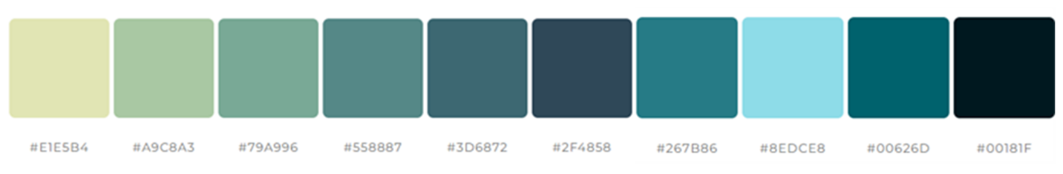**Color Palette:** Black, Blue, Turquoise, Green, Yellow

**Character Design:** In 2D-pixel art design

* The Monkey: He has brown fur and he’s holding a gun.
* The Head Scientist (boss): He has a hunched figure with exaggerated features to evoke menace while maintaining a sense of caricature. He is wearing a lab coat and glasses. He has a visually intimidating presence.
* Other scientists (allies of the main scientist): They have simple designs with basic lab coats and minimal equipment. They are smaller than their boss and are each equipped with a gun to chase the monkey.

**Environment Design:**

* 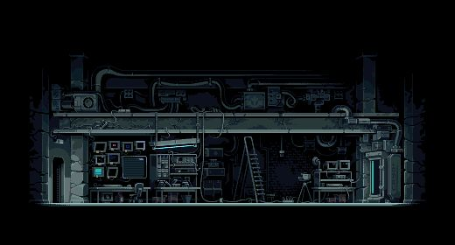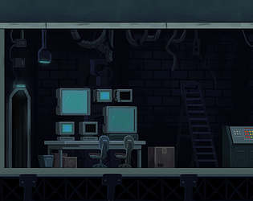Lab Environment: The lab has a cold, mechanical aesthetic, using a muted color palette dominated by sad colors like blue. The lighting in the lab is harsh and artificial to create an atmosphere that should feel oppressive and stressful.
* 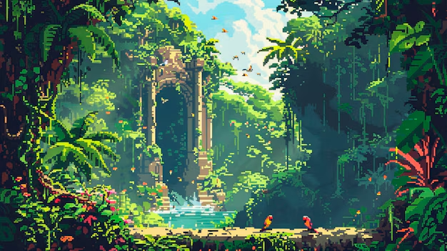Jungle Environment: The jungle features vibrant, saturated colors such as greens, deep browns, and bright blue that signify life, freedom, and natural beauty. It also has trees, plants, and overall, all the things that a jungle has to create a tranquil yet adventurous mood.

# ***UI Storyboard***

**Main Menu Screen:**

* **Background:** a clinical lab environment, with cold metallic surfaces and dim lighting.
* **Title:** “Monkey Goes Bananas: Lab Escape”
* **Menu option:** a pixelated button written “Let’s play” to start the game.

**In-Game Characters/Objects Display:**

* The Monkey:
* **Position:** Start at the left of the screen. Can move around the map.
* **Design:** Press ←, →, ↑, ↓ to move around the map and press ___ to shoot the enemies.
* Scientists:
* **Position:** all around the map
* **Design:** Move automatically toward the monkey
* Bananas:
* **Position:** Displayed randomly all around the map, hidden in boxes
* **Design:** Is collected by the monkey to power up

**Power-Up effect:**

* **Design for common power-up:** Common power-ups will be represented by individual bananas that are hidden in boxes that the player will encounter during gameplay. Once broken, the box reveals the banana which, when consumed, will increase the player’s physical size for a brief amount of time while also decreasing damage intake.
* **Design for rare power-up:** Also hidden in boxes, the rare power-up takes the form of a scientific vial containing vibrant green fluid. Once ingested, the player is granted increased firing speed for a brief period.

**Transition Screen:**

* **Lab to Jungle:** When the player defeats the main boss, a brief transition cutscene will play and it will teleport the player to the jungle (Victory screen).
* **Lab to another Lab:** When the player finishes doing all tasks of the first lab, it will have a quick transition from the first lab to the second lab.
* **Lab to Cell:** When one of the enemies captures the player, a transition cutscene will play and it will teleport the player to the cell of the monkey (Game Over screen).

**Boss Fight UI (Final Battle):**

* The Head Scientist:
  + **Position:** on the right corner of the screen
* The Monkey:
  + **Position:** on the left center of the screen

**Victory/Game Over Screen:**

* Victory Screen
* **Background:** The screen will display a pixelated animation of the jungle, with the monkey standing triumphantly in front of its home.
* **Text:** “Congratulations, you have won the game! You’ve escaped the lab and returned home!”
* **Button Prompts:** Options to Continue (to replay stages or a bonus level) or Return to the Main Menu.
* Game Over Screen
* **Background:** The screen will show the lab cell closing and the monkey sitting in defeat inside, with soft light flickering from the lab machines outside the cell.
* **Text:** “Game Over! You’ve been captured. Try again.”
* **Button Prompts**: Options to Retry or Return to Main Menu.

# ***Tags & Dialogue***

**Tags:**

|  |  |  |
| --- | --- | --- |
| Gameplay Tags | Environment & World Tags | Character & Story Tags |
| * 2D Platformer * Action-Adventure * Pixel Art * Escape Game * Puzzle Elements * Boss Battle * Power-Ups * Single Player * Environmental Puzzles * Stealth Elements * Combat | * Laboratory * Jungle * Sci-Fi * Science Experiments * Animal Testing * Escape Mission | * Monkey Protagonist * Experimentation * Revenge * Freedom * Rebellion * Scientist Boss * Lab Guards * Jungle Return * Boss Fights |

**Dialogue:**

# ***Tech Plan***

**Tools to make the game:**

* Design Document: *Word*
* Artist tools:  *Google Image, Paint, AI generator*
* Programmer tools: *Greenfoot, Java…*

# ***Software Architecture***

The software architecture of this game is Greenfoot, an IDE that makes game based on Java/Stride.

# ***Controls***

Because our games are played mostly on a computer our keys to move will be either A, D, W, S or ←, →, ↑, ↓ to move up, down, left, and right, and for the shooting of the gun you would use the space bar but if you are playing with control it would be very similar as the keys used to move are of course the arrow keys and to shoot it would be the on the front of the controller.

# ***Level Design***

* Level 1:
* Monkey got out of the lab cell and has to defeat scientist guard to go to the next level (another lab area).
* Level 2:
* New lab area where monkey can power up and defeat other scientists to go to the next level (another lab area with more enemies and bananas)
* Level 3:
* Same as the level 2
* Final level:
* Fight with the scientist boss in the scientist office to get the key to unlock the lab door to gain freedom.

# ***Mechanicals Analysis***

**Protagonist and Storyline:**

* Protagonist: A lab-monkey, drawing inspiration from Rise of the Planet of the Apes. Gives a personal and emotional touch to the gameplay.
* Objective: Fight through lab employees to reach and defeat the final boss—the head scientist. Victory means freedom, while defeat results in a jail-like ending.

**Gameplay Mechanics:**

* Shooting & Combat: Core mechanic revolves around shooting enemies, reminiscent of Asteroids, with added complexity from progressive difficulty.
* Platform Navigation: Borrowed from Super Mario Bros, requiring players to navigate through the lab environment, adding a layer of strategic movement.

**Power-Ups:**

* Banana: Temporarily increases player strength by decreasing damage intake and increasing size—provides visual feedback to players.
* Lab Vial: Increases firing rate, allowing for rapid shooting, adding variety and strategic depth to combat.

**Boss Battle:**

* Final Boss: The head scientist serves as the ultimate challenge, ensuring that the climax of the game is intense and rewarding.

**Win/Lose Conditions:**

* Winning: Achieving freedom, showcased with a jungle backdrop.
* Losing: Capture, depicted by a monkey behind bars—high stakes to motivate players.

# ***Schedule***

* Game Proposal

Due: **October 3**

* Game Design Document

Due: **October 17**

* Game Project Implementation

Due: **November 28**

* Project Presentation + PPT Slides

Due: **December 3 & 5**

# ***Budget***

Our budget is 0$.

# ***Change Log***

|  |  |
| --- | --- |
| Date | Changes Made |
| 2024-10-16 | Finished the first part of the Game Design Document by Everyone |
| 2024-10-17 | Add some detail information by Kaci |
|  |  |
|  |  |
|  |  |
|  |  |
|  |  |